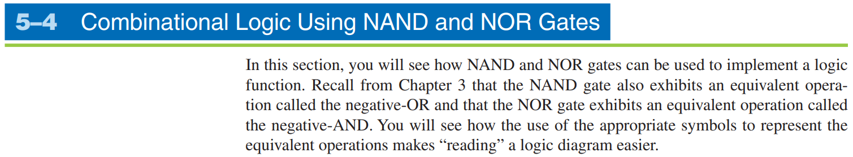

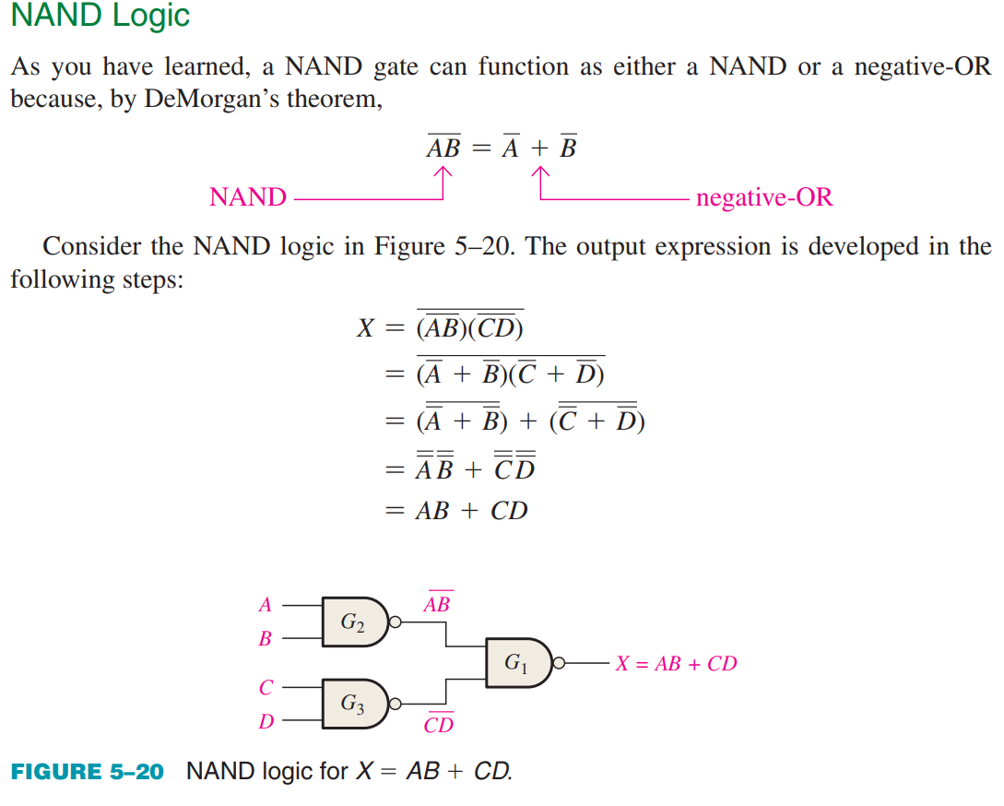

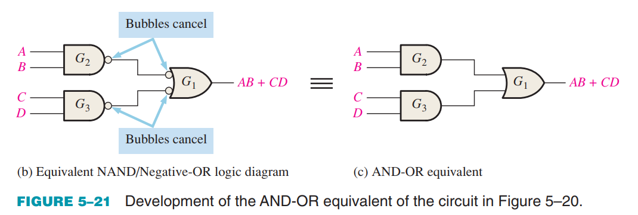

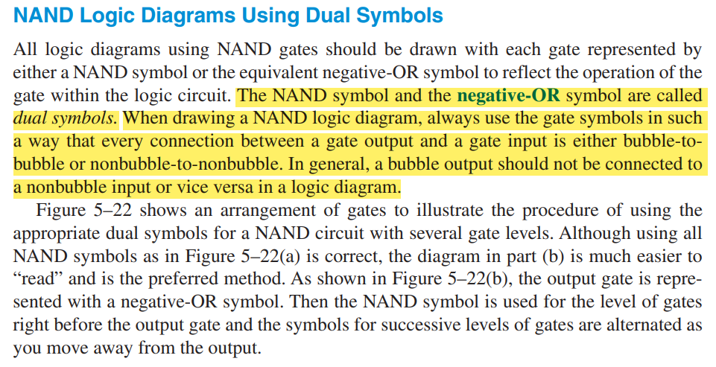

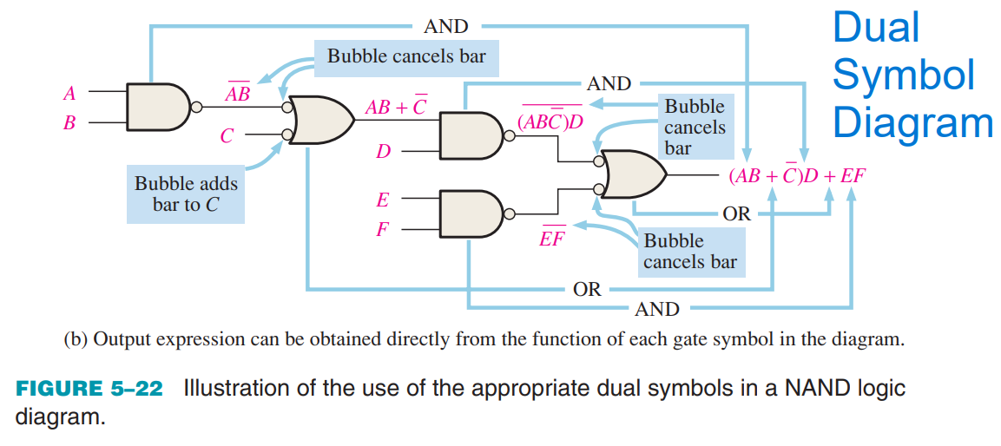

Look at the given diagram and decide if you want to do bubble-to-bubble or non-bubble to non-bubble. You can usually do both, but which gates, examine carefully and see where are the gates getting cancelled or if not cancelling then just replace the first gate with Negative-OR it will be non-bubble to non-bubble. You cannot do non-bubble to bubble or vice versa.



